Project Description:

This GAB program is for standard BOM uploads, with an optional INVENTORY upload feature. The excel spreadsheet format in file AEGIS BOM IMPORT TEMPLATE.xls was used to format the BOM, INVENTORY and XREF uploads. If a spreadsheet is used for an upload and does not match this file's formatting the program will not function in the way it was designed. When you choose to do an Inventory Upload the program will automatically do a Cross Reference Upload also.

Installation:

All necessary files are contained in the attached ATG_BOM_Upld_Opt_INV_Upld.ZIP file
You must be running Global Shop version 2011.3 to run this program.
The GAB Client needs to have been run on any workstation that will be using the delivered GAB script.
It is very important that the latest hotfixes have also been installed.

You must have the “Use Part Cross Reference” selection checked in your System Support >>> Company Options (Advanced) >>> Inventory settings.

Put the UPLINV file in your \\GLOBAL\PRGMS folder

Put the ATG_BOM_Upld_Opt_INV_Upld.GAS and ATG_BOM_Upld_Opt_INV_Upld.GAS.SIG files in your \\Global\Plugins\GAB\GAS folder.

The BOMTemplate.xls file may be stored anywhere that is convenient for BOM upload use.

This program will be set up to launch from a custom menu item.

Create Custom Hook, and attach script to hook: (You may need to be logged in as SUPERVSR)
-Navigate to System Support>Administration>GAB Script Hook Maintenance
-Click 'New Hook', make note of new hook number
-Enter in Hook Description, Ex. 'BOM upload with Opt INV upload'
-Click 'New Seq'
-Click on the magnifying glass button next to GAS field
-Navigate to Global\Plugins\GAB\GAS\ATG_BOM_Upld_Opt_INV_Upld..GAS file
-Click 'Save Seq'
-Check the Active Hook check box if not already checked.

Create Custom Menu Item: (You may need to be logged in as SUPERVSR)
-Custom Menu Item can be added to any area, this example creates a custom menu item in the Bill of Material Menu
-Navigate to Bill of Material
-Right Click on 'File'
-Select 'Add Custom Menu Item'
-Select Type as GAB
-Give a descriptive title, Ex.'BOM Upload with optional Inventory Upload'
-Click the Hook browser
-Select the custom hook created above from hook browser
-Hit 'Save'
-Set the Permissions for custom menu item
-Click 'Add User'
-Add all users who are going to use this custom menu item
-Once all users have been added click 'Save'
-A log out and log in to the Global Shop Menu is required before custom menu item can be used
-After logging back into to Global Shop, the custom menu item will be functional

Running the Program:

When you select your program from the custom menu item the first screen you will encounter is a browser screen to find the BOM parent part .xls file you want to upload to Global Shop the default location is \\Global\Files. Double click the .xls file you want to use for your BOM and/or INV upload.
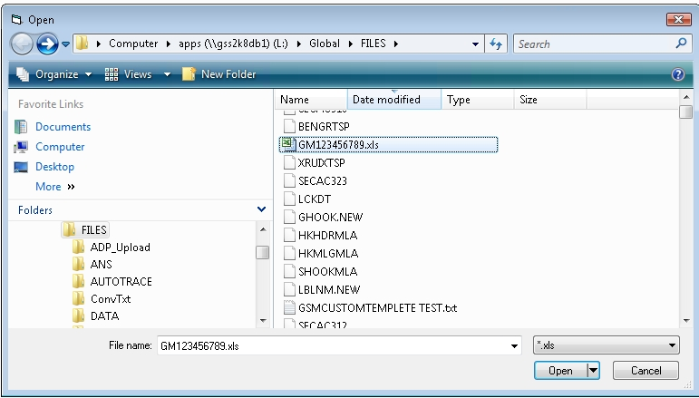

If the BOM parent already exists in Global Shop you will be prompted to append or overwrite the existing BOM. Clicking “OK” will continue the program and “CANCEL” will stop the program entirely.

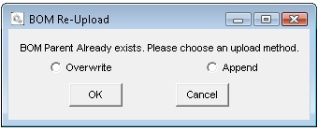

Next you will be prompted if you would like to initiate an Inventory Upload. Clicking “Yes” will run an Inventory and Cross Reference upload. Clicking “No” will skip the Inventory and Cross Reference uploads and continue to the BOM upload.

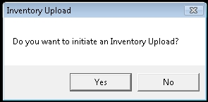

You may see other status screens pop up, the only remaining popup will be the cross reference upload status screen. Simply click “Exit” when it appears.

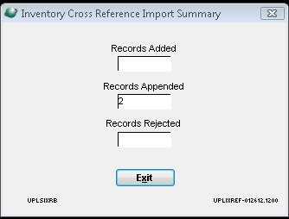

The BOM upload will run automatically and will not generate any prompts.

The final popup will notify you that the uploads are complete.

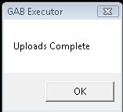

As part of the program cleanup, the INV.TXT, BOMC.TXT and XREF.TXT files will be deleted after they are used for an upload. The .xls BOM Parent file will be moved to a folder where the upload file originated from, named “UploadComplete”.

This project was developed for a specific customer with their criteria inserted into the program. Use of this program on another system will require additional development and modifications.

